LAKE ANNA PLAZA OWNER’S ASSOCIATION

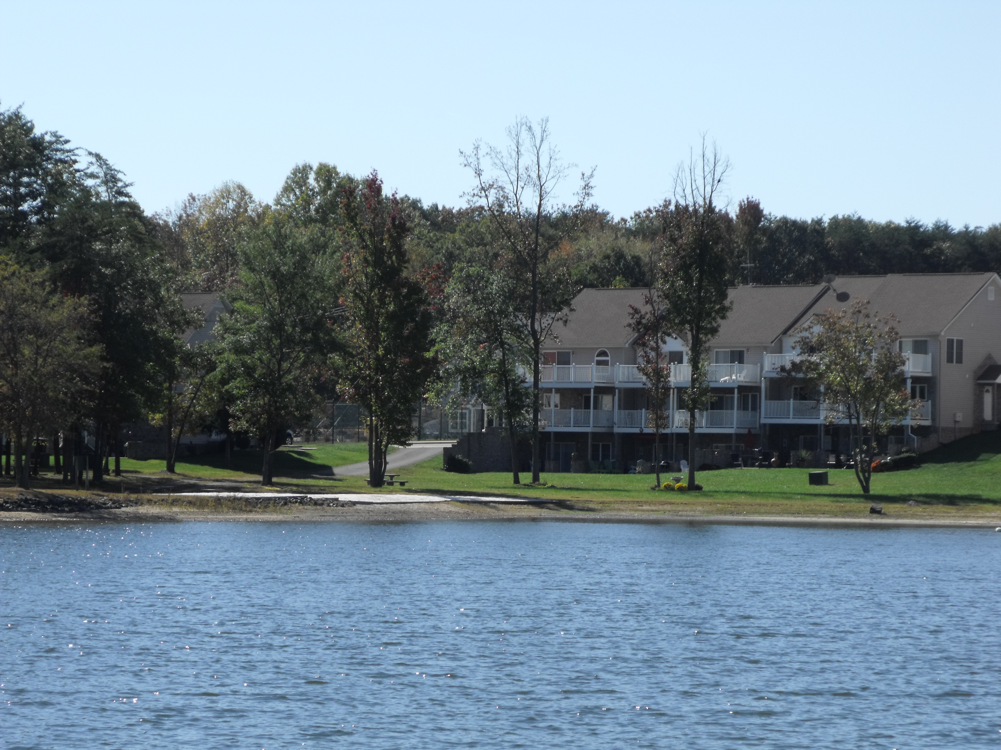

RENTERS GUIDE

May 2020

LAKE ANNA PLAZA OWNERS ASSOCIATION
RENTERS GUIDE

Lake Anna Plaza is a blend of both permanent residents and investor-owners. The permanent residents include families who live here on a full-time basis and some who use it as a get-away. It is important that we all be courteous and respectful of each other’s rights. In order to ensure that everyone has a pleasant experience and to protect our neighborhood and property values, the Association Members have agreed on this set of guidelines which supplement the Restrictive Covenants contained in the Declarations, Article VI. Please remember that renters are required to comply with the LAPOA Rules and Regulations while renting a unit in the Lake Anna Plaza.

Lake Anna Plaza Homeowners Association Board of Directors
ALTERATIONS TO THE UNIT EXTERIOR MUST BE APPROVED IN ADVANCE

It is very important that you not undertake to alter the exterior of your unit in any way without the approval of your unit owner or your rental agent. They must obtain approval from the LAPOA Architectural Review Board (ARB) before any changes may be made.

PARKING

Parking is limited. Each unit is entitled to two parking spaces but only one space per unit is guaranteed. Although spaces are not marked, please assume that the parking space closest to each unit is “reserved” for that resident. All other spaces are usable on a first come basis. Please observe the “no parking” law in designated fire lanes. Park only in designated parking spaces and do not parallel park next to the curbs on the roadways.

No boats, trailers, or jet skis and other equipment may be parked in the residential parking spaces and may be subject to towing at the owner’s (or homeowner’s) expense. That includes the parking spaces by the tennis courts and the open area at the west end of Lakefront Dr. They simply may not be parked on the roadways of the development. They are not allowed on lawns or the common areas at any time. Boats, trailers and jet skis may be parked in the permanent boat and trailer storage area which may be accessed through the gravel road at the west end of Lakefront Dr. Access is controlled by a locked chain/gate. Please be sure to ask your rental agent/owner for the combination. This combination will also open the locks on the boat launch ramp road and the tennis courts.

DOGS AND OTHER PETS

No animals, except common domestic household pets may be kept, maintained or cared for on any lot or within the property. Dogs and other pets are welcome at Lake Anna Plaza – if your rental agreement allows them. No more than two (2) dogs or cats or caged birds, or any combination thereof, may be kept or maintained on any lot or within any unit.

Pets must be on leash at all times. Pets may be tethered but the length of the tether must be reasonable and prevent the pet from encroaching on your neighbor’s space. Pets, regardless of size, must be controlled by their owners at all times. Excessive barking, howling or other noises are not allowed. Owners are responsible for their pets. Be especially diligent with your pets. Remember even the most friendly pets can be threatening to children and even adults.

Pooper-scooper rules apply. Pet owners must pick up and properly dispose of pet waste immediately. Cleaning up after pets is both courteous and sanitary.

BOAT RAMP

Tow vehicles and trailers must be removed from the ramp and common area immediately after launch or recovery. Cars, trucks, trailers and other watercraft and equipment may not be parked in the ramp or common areas.

TENNIS COURT

The tennis court is available for anyone’s play, first come-first serve (no pun). If another group is waiting please limit you game to one set. In no case should the tennis court be used after 10:00PM.

DOCK SPACE/BOAT SLIPS

Lake Anna Plaza townhomes in units A through H have been assigned one boat slip. Renters, please check with the homeowner or your agent to determine which dock slip, if any, is available for your use. Please be respectful of other residents’ dock areas and do not park your watercraft in a slip just because it appears empty. The owner may be out on the water and would like to have access to their slip when they return. Because the dock walkways are narrow, please do not set lawn chairs, or leave fishing equipment, toys or other accessories on the dock.

BOATS AND JET SKIS

Please do not bring boats or jet skis into the areas by the beach.

JET SKI DOCKS

Renters may only use a jet ski dock that belongs to the owner of their rental unit, for as long as the term of their rental and provided your rental agreement allows that. Again, please do not use a jet ski dock just because it appears to be empty at the time. Jet ski docks are all privately owned.

JET SKI PARKING RULES
If you do not own a Jet Ski dock, you may temporarily tether your jet ski in the cove when you are present. Please do not tether the Ski in a way that blocks or interferes with the area in front of F, G and H units, the area by the sandy beach or the area between A and B docks. It is also permissible to temporarily secure your Jet Ski to the main walkway of any dock on the side opposite the boat slips. Please don’t tie up to the side of an end slip unless you have that owner’s permission to do so.

USE OF TENTS OR HAMMOCKS AS OVERNIGHT ACCOMMODATIONS
The use of tents for overnight accommodations is limited to one tent per unit and it must be located on that unit’s property. The use of tents or hammocks in the common area for overnight accommodations is prohibited. Any and all sleeping overnight in the common areas is prohibited.

Please Don’t Feed Ducks and Other Wild Animals
Virginia has declared it illegal to feed wild animals when the feeding results in property damage, endangers people or wildlife or creates a public health concern. Feeding creates an artificial food supply which can cause the animals to remain in the area and it can upset their normal habits and make them dependent. For these reasons, LAPOA policy is that we not feed ducks or any wild animals.

GARBAGE

All garbage and recyclables should be taken to the Louisa County Recycling Center on Route 522 across the street from Dickinson’s store or otherwise removed at the end of your stay. Do not leave open garbage or garbage bags on the front steps. Garbage temporarily stored on patios should be in heavy duty, tightly closed containers and removed promptly. Owners are responsible for the removal of their own and any renter’s trash. If you have a garbage service, garbage cans may not be left out front in public view on non pickup days.

NO WAKE AREAS

Please observe the “No Wake” policy on the shore-side of the no wake buoy markers and around the boat dock and surrounding areas for the safety of swimmers and as a courtesy to fellow boat owners.

COMMON PICNIC AREAS

Common picnic areas are for the use of all residents on a first come basis. Please be courteous to others and police the area when you leave. All garbage, bottles and other debris must be disposed of immediately following use. Please do not leave anything on the common area picnic tables overnight. In those situations where the picnic area has not been properly cleaned, the Association will make arrangements to complete the clean up and the responsible owner will be asked to reimburse the Association.

SWIMMING AND PLAY

To minimize the Association’s liability, no swimming is allowed. You assume complete risk for any accident/injury that occurs. The Association does not provide supervision or “lifeguards”. All other activities, tennis, volleyball, etc. are at participants’ risk.

NOISE AND MUSIC

The following is a quote from Louisa County Ordinances concerning noise.

“It shall be unlawful to create any unreasonable loud, disturbing and unnecessary noise in the county and noise of such character, intensity and duration as to be detrimental to the life or health of any person or to unreasonably disturb or annoy the quiet, comfort or repose of any person, is hereby prohibited.”

Respect your neighbors. Noise and music generally should not be heard past the owner’s patio area or front door of your unit. All parties, including those in the picnic/common areas should also turn off any music and reduce noise levels after 11:00 PM during the week and 12 midnight on Fridays and Saturdays.

LAWN & COMMON GRASSY AREAS

Cars, trucks, trailers and other motorized vehicles such as ATVs, motorcycles, etc., are not allowed on the lawn areas at any time. Please do not bring personal vehicles to the patio areas or other common grassy areas. Violators (or the homeowner) will be responsible to financially or physically repair resulting damage. Maintenance or emergency vehicles only are allowed on the lawns or grassy areas when weather conditions permit their operation.

FIREWORKS

The use of fireworks in the LAPOA development is strictly prohibited. Under all circumstances the unit owner, including rental situations, is responsible for any damage resulting from the use of fireworks.

VIRGINIA STATE FIRE CODES

Virginia Fire Code does not permit the placement of outdoor barbecue equipment on any elevated porch structure. Please comply with the requirements and only use barbeque pits on the concrete patios.

SPEED LIMIT

The speed limit on all roads in the community is 15 MPH.

EMERGENCY TELEPHONE NUMBERS

If you need to dial 911, please do so from a land line so that your call can be traced by the emergency dispatcher. Dialing from a cell phone will not provide the dispatcher the information he/she needs in order to facilitate reaching you.

Sheriff Offices:
Spotsylvania – 540-854-6520
Louisa – 540-967-1234
State Police – 1-800-552-9965
Fire Department – 540-894-5660

.

